Dokumentasi Database

# **Table User**

Entitas: users

Primary key: id

Atribut: id,name,role,images_profile,email,email, email_vertifed

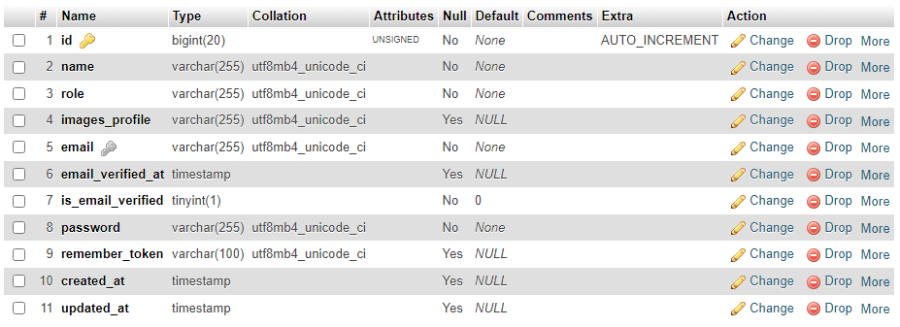

|  |  |
| --- | --- |
| **Field** | **Keterangan** |
| id | Id user saat daftar /register |
| role | Hak akses default user |
| Images_profile |  |
| email |  |
|  |  |
|  |  |
|  |  |

# **Table User Verify**

Entitas: users_verify

Atribut: user_id, token, created_at,update_at